Supplementary material
Vortioxetine for depression in adults: a systematic review and dose-response meta-analysis of randomized controlled trials

Summary
Supplementary Table S1. Search strategy

Supplementary Figure S1. Risk of bias assessment of the included studies.
Supplementary Figure S2. Meta-analysis of vortioxetine versus placebo: Response rate.
Supplementary Figure S3. Meta-analysis of vortioxetine versus SSRIs: Mean change in depression symptom scores.
Supplementary Figure S4. Meta-analysis of vortioxetine versus SNRIs: Mean change in depression symptom scores.
Supplementary Figure S5. Meta-analysis of vortioxetine versus placebo: Dropout rate for any reasons.
Supplementary Figure S6. Meta-analysis of vortioxetine versus placebo: Dropout rate for adverse events.
Supplementary Figure S7. Meta-analysis of vortioxetine versus placebo: Adverse events.
Supplementary Figure S8. Meta-analysis of vortioxetine versus placebo on mean change in depression symptom scores: Subgroup analysis based on dose.
Supplementary Figure S9. Meta-analysis of vortioxetine versus placebo on response rate: Subgroup analysis based on dose.
Supplementary Figure S10. Meta-analysis of vortioxetine versus placebo on dropout for any reasons: Subgroup analysis based on dose.
Supplementary Figure S11. Meta-analysis of vortioxetine versus placebo on dropout for adverse events: Subgroup analysis based on dose.
Supplementary Figure S12. Meta-analysis of vortioxetine versus placebo on adverse events: Subgroup analysis based on dose.
Supplementary Figure S13. Sensitivity analyses on the mean change in depression symptom scores.
Supplementary Figure S14. Spline curves with different knots and their goodness-of-fit.
Supplementary Figure S15. Dose-outcome curves for only fixed-dose studies.
Supplementary Figure S16. Dose-outcome curves estimated using a one-stage (blue line), a two-stage (red line) restricted cubic spline model and a two-stage linear (green line) model.
Supplementary Figure S17. Funnel plot for assessing the publication bias for mean change in depression symptom scores.
Supplementary Figure S18. Meta-analysis of vortioxetine versus SNRIs on mean change in depression symptom scores: Subgroup analysis based on different SNRIs.

Supplementary Table S1. Search strategy.
PubMed
No. | Query | Results
1 | depressive disorder[MeSH Terms] OR depressive disorder, major[MeSH Terms] OR mood disorders[MeSH Terms] OR dysthymic disorder[MeSH Terms] OR depression[Text Word] OR depressive[Text Word] OR depressed[Text Word] OR dysthymia[Text Word] OR dysthymic[Text Word] OR affective symptoms[MeSH Terms] OR mdd[Title/Abstract] OR affective disorders[All Fields] | 704661
2 | "vortioxetine"[MeSH Terms] OR "vortioxetine"[Title/Abstract] OR "Lu AA21004"[All Fields] | 731
3 | (randomized controlled trial[Publication Type] OR controlled clinical trial[Publication Type] OR randomized[Title/Abstract] OR placebo[Title/Abstract] OR double-blind[Title/Abstract] OR controlled[Title/Abstract] OR randomly[Title/Abstract] OR trial[Title/Abstract] OR groups[Title/Abstract]) NOT ("animals"[MeSH Terms]) | 926749
4 | 1 AND 2 AND 3 | 66

Cochrane Library
No. | Query | Results
1 | (depression):ti,ab,kw OR ('depressive disorder'):ti,ab,kw OR (depressed):ti,ab,kw OR ("mood disorders"):ti,ab,kw OR ("affective disorders") (Word variations have been searched) | 116423
2 | MeSH descriptor: [Depression] explode all trees | 17908
3 | MeSH descriptor: [Depressive Disorder, Major] explode all trees | 7079
4 | 2 OR 3 | 22861
5 | 1 OR 4 | 116423
6 | (Vortioxetine):ti,ab,kw OR (Lu AA21004) | 315
7 | MeSH descriptor: [Vortioxetine] explode all trees | 180
8 | 6 OR 7 | 315
10 | (randomized controlled trial):pt OR (controlled clinical trial):pt OR (randomized):ti,ab,kw OR (placebo):ti,ab,kw OR (randomly):ti,ab,kw OR (trial):ti,ab,kw OR (groups):ti,ab,kw | 1690820
11 | 5 AND 8 AND 10 | 244

Embase
No. | Query | Results
1 | 'vortioxetine'/exp OR vortioxetine:ti,ab,kw OR 'lu aa21004' | 2110
2 | 'mood disorders':ti,ab,kw OR depressed:ti,ab,kw OR 'depressive disorder':ti,ab,kw OR depression:ti,ab,kw OR 'major depressive disorder':ti,ab,kw OR mdd:ti,ab,kw OR 'affective disorders' | 737337
3 | 'randomized controlled trial'/de OR 'controlled clinical trial'/de OR 'randomization'/de OR 'intermethod comparison'/de | 1332529
4 | random*:ti,ab,kw OR placebo:ti,ab,kw OR compare:ti,tt OR compared:ti,tt OR comparison:ti,tt OR ((evaluated:ab OR evaluate:ab OR evaluating:ab OR assessed:ab OR assess:ab) AND (compare:ab OR compared:ab OR comparing:ab OR comparison:ab)) OR (open NEXT/1 label):ti,ab,tt OR ((double OR single OR doubly OR singly) NEXT/1 (blind OR blinded OR blindly)):ti,ab,tt | 5019057
5 | 3 OR 4 | 5396643
6 | 1 AND 2 AND 5 | 551

Web of Science
No. | Query | Results
1 | (TS=(vortioxetine)) OR TS=(Lu AA21004) | 1420
2 | (((((TS=(depression)) OR TS=(depressive disorder)) OR TS=("mood disorders")) OR TS=(depressive)) OR TS=("affective disorders")) OR TS=(MDD) | 1269453
3 | ((((((((TS=(randomized controlled trial)) OR TS=(controlled clinical trial)) OR TS=(randomized)) OR TS=(placebo)) OR TS=(random*)) OR TS=(trial)) OR TS=(groups)) OR TS=(blind* ) | 18572497
9 | 1 AND 2 AND 3 | 553

Supplementary Figure S1. Risk of bias assessment of the included studies.
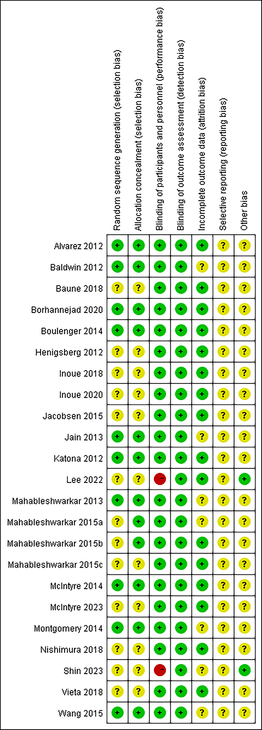

Supplementary Figure S2. Meta-analysis of vortioxetine versus placebo: Response rate.
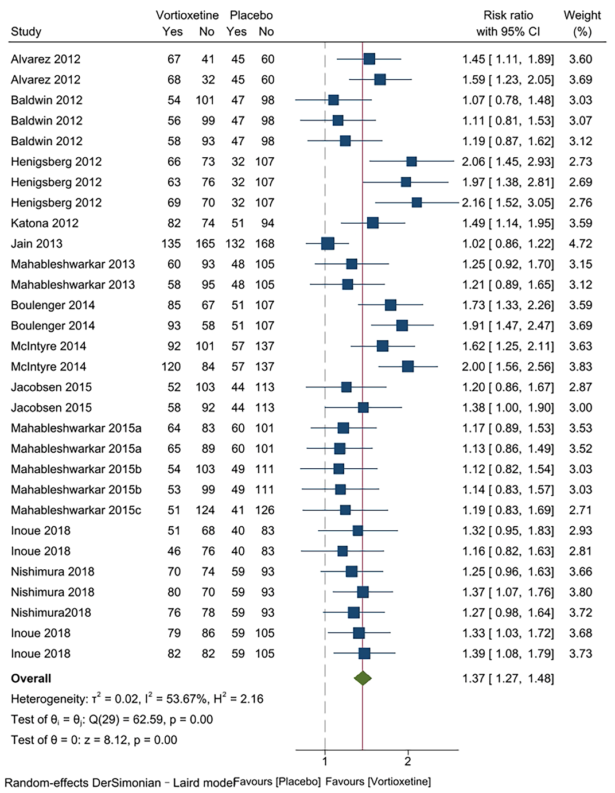

Supplementary Figure S3. Meta-analysis of vortioxetine versus SSRIs: Mean change in depression symptom scores.
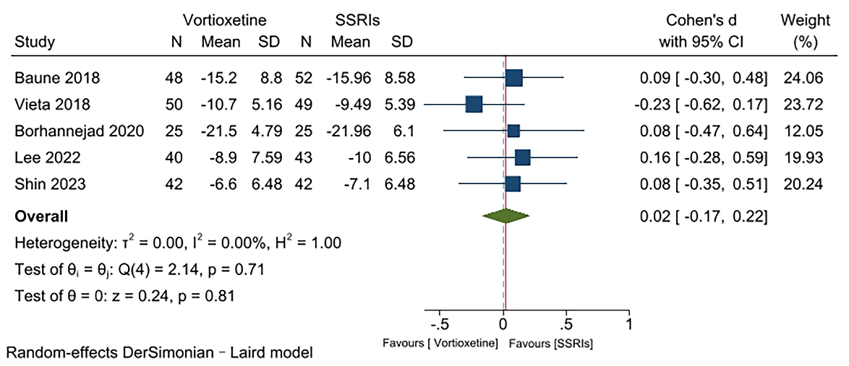

Supplementary Figure S4. Meta-analysis of vortioxetine versus SNRIs: Mean change in depression symptom scores.
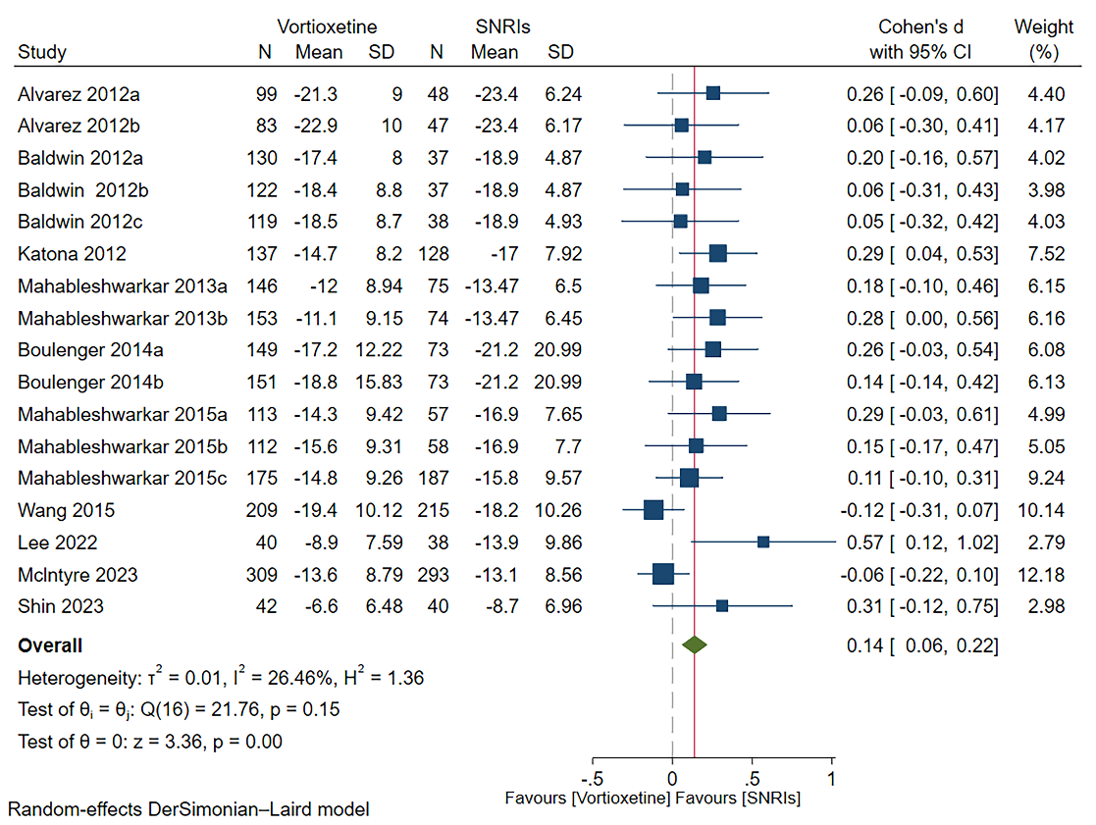

Supplementary Figure S5. Meta-analysis of vortioxetine versus placebo: Dropout rate for any reasons.
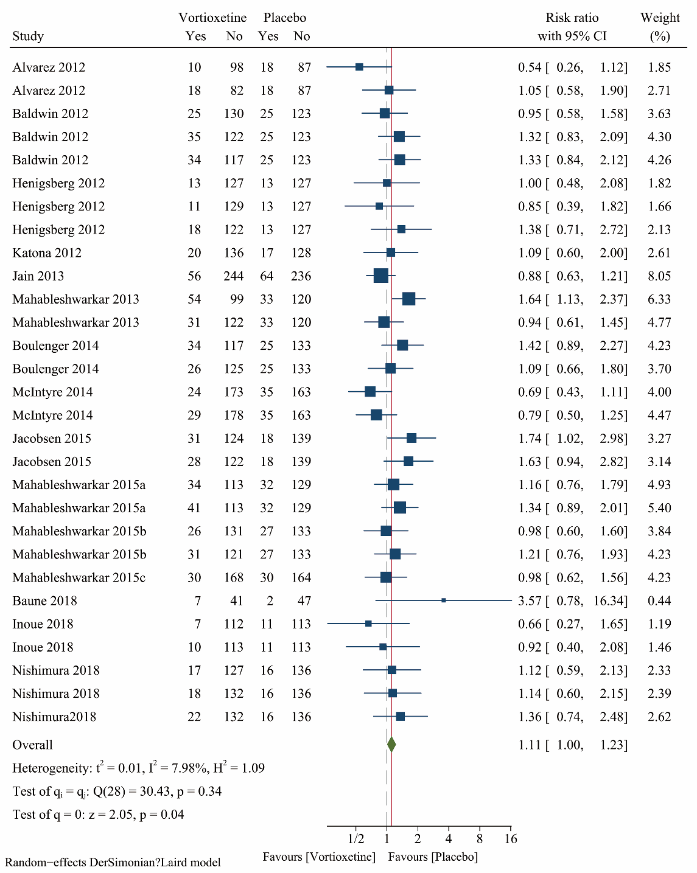

Supplementary Figure S6. Meta-analysis of vortioxetine versus placebo: Dropout rate for adverse events.
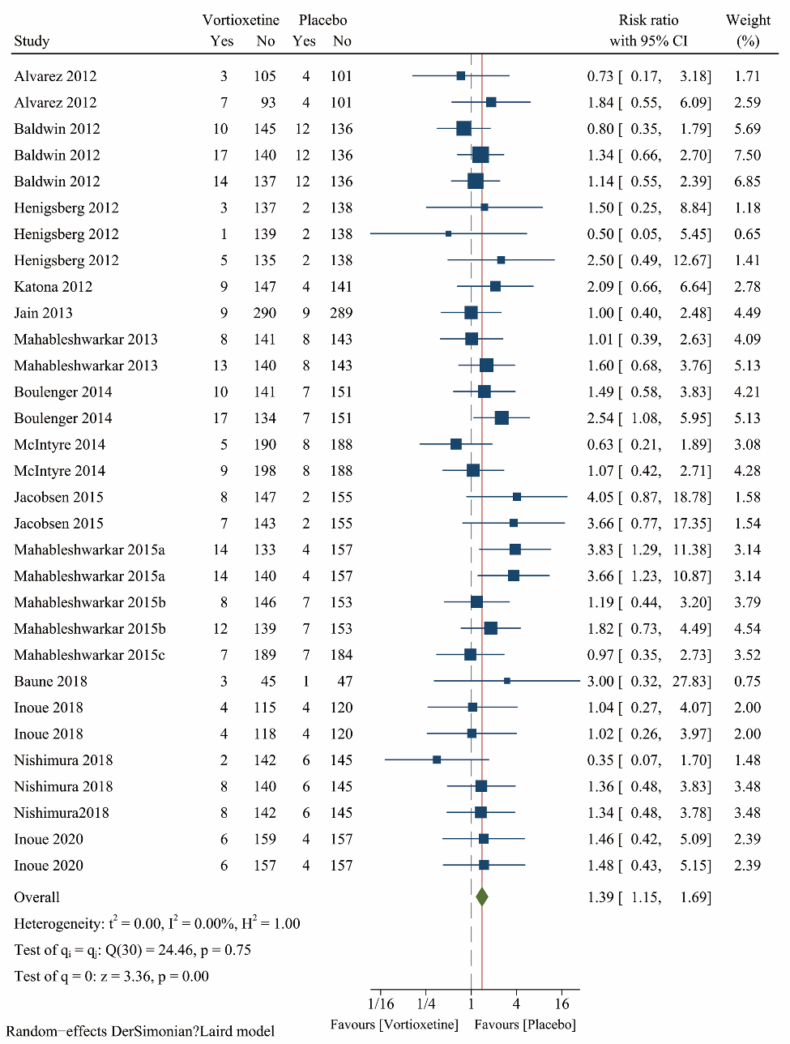

Supplementary Figure S7. Meta-analysis of vortioxetine versus placebo: Adverse events.
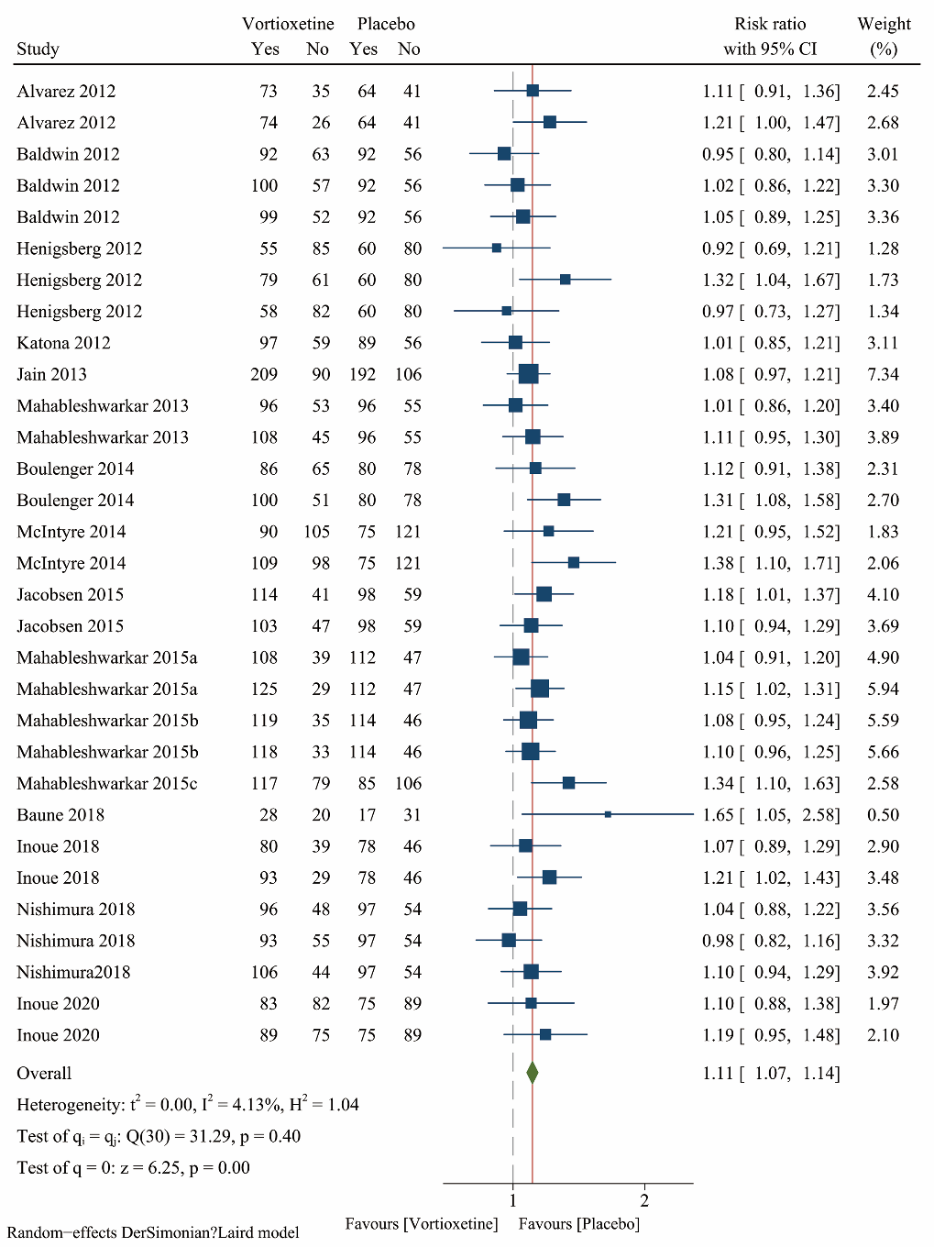

Supplementary Figure S8. Meta-analysis of vortioxetine versus placebo on mean change in depression symptom scores: Subgroup analysis based on dose.
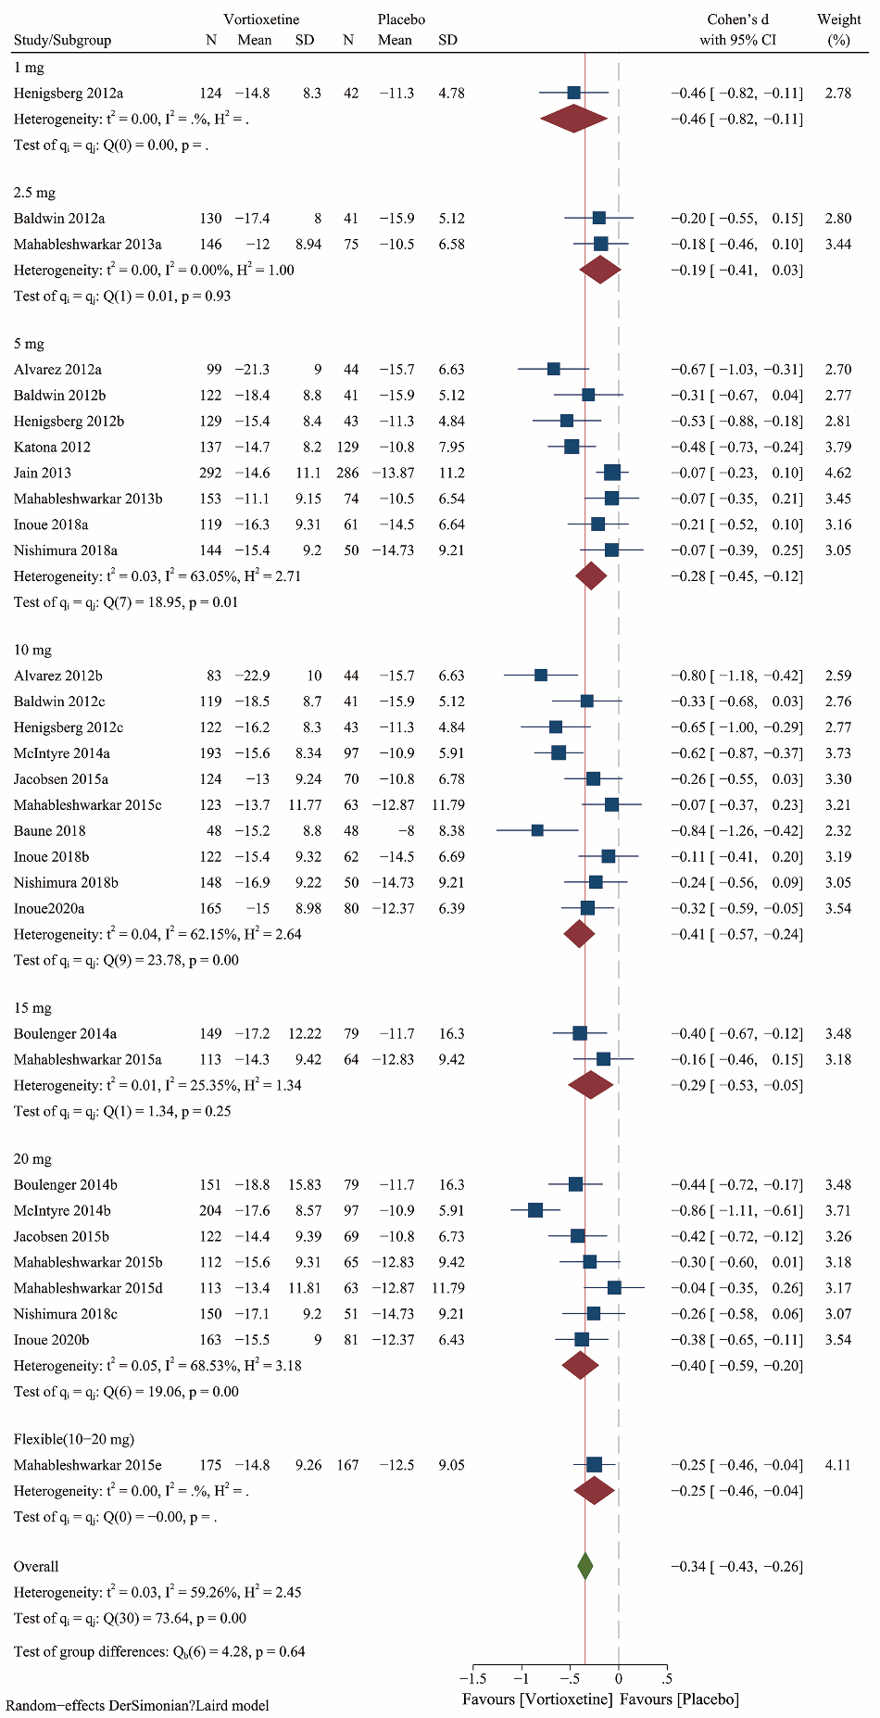

Supplementary Figure S9. Meta-analysis of vortioxetine versus placebo on response rate: Subgroup analysis based on dose.
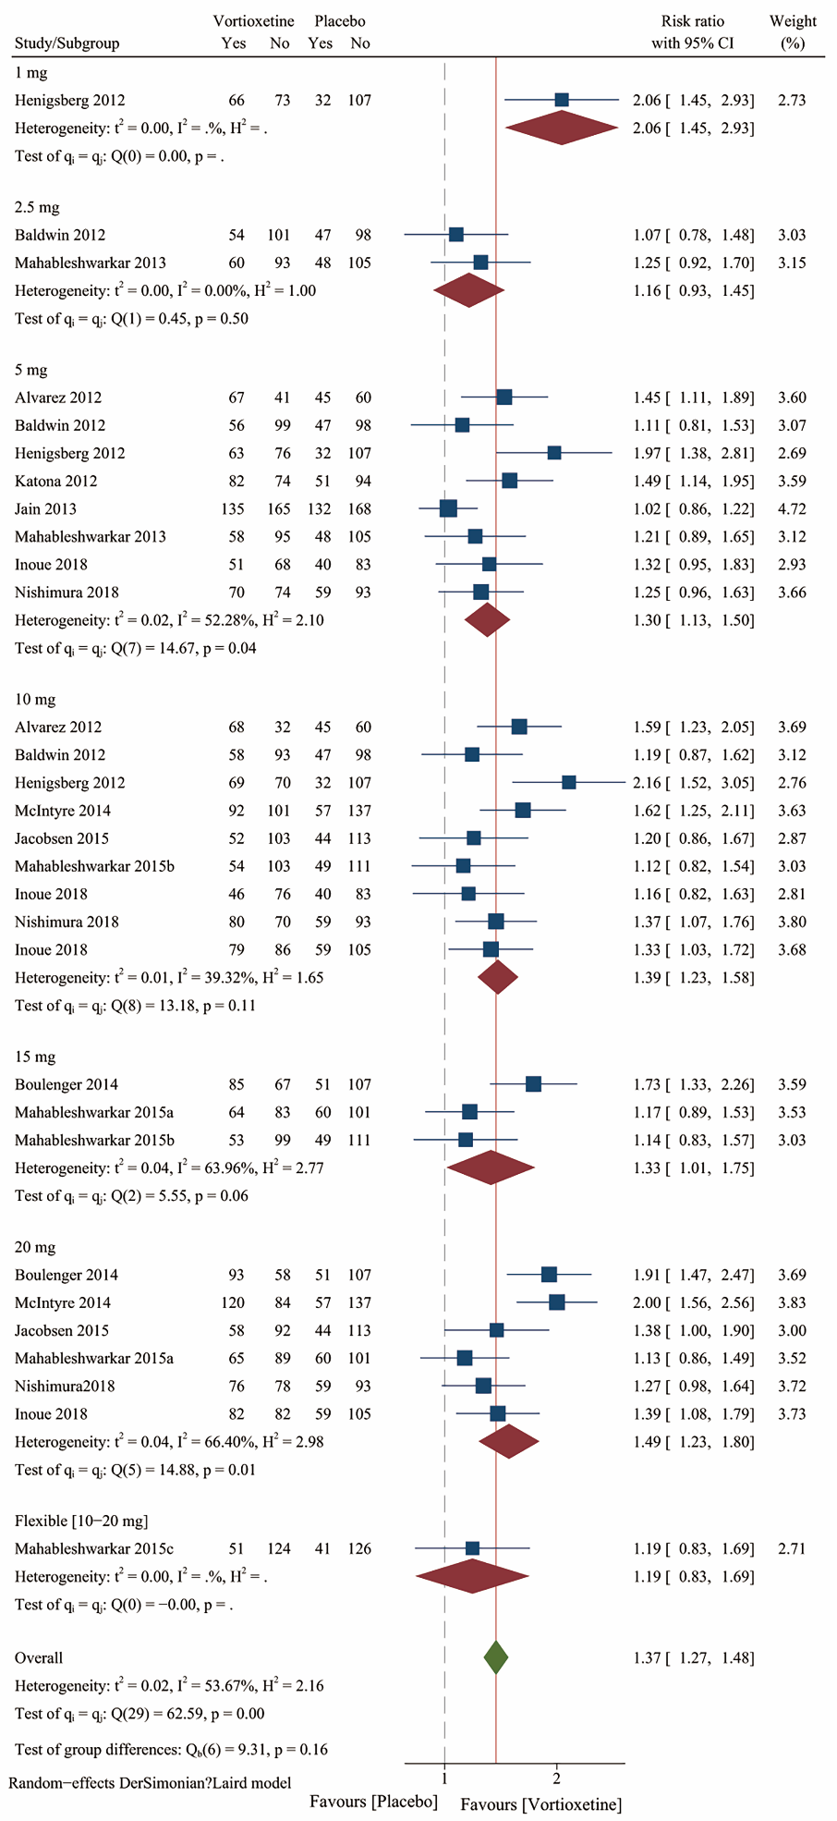
Supplementary Figure S10. Meta-analysis of vortioxetine versus placebo on dropout for any reasons: Subgroup analysis based on dose.
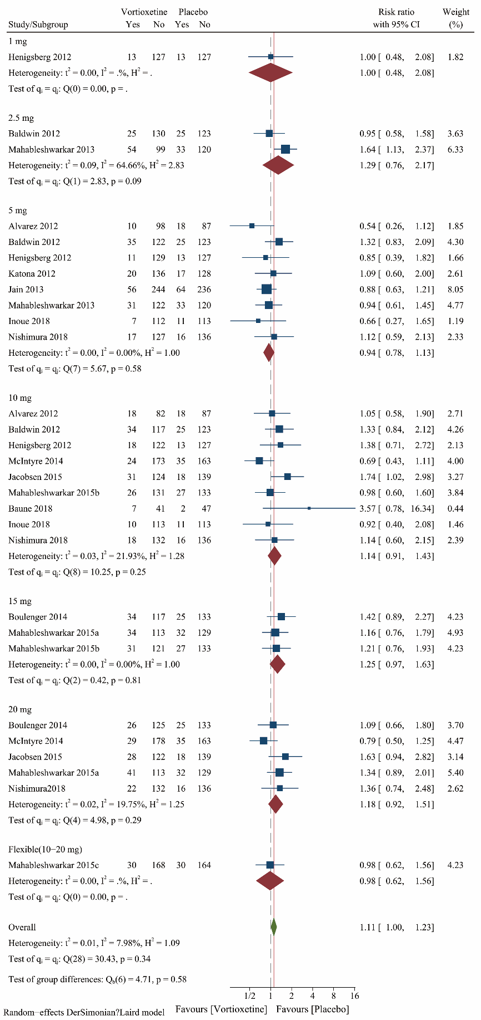

Supplementary Figure S11. Meta-analysis of vortioxetine versus placebo on dropout for adverse events: Subgroup analysis based on dose.
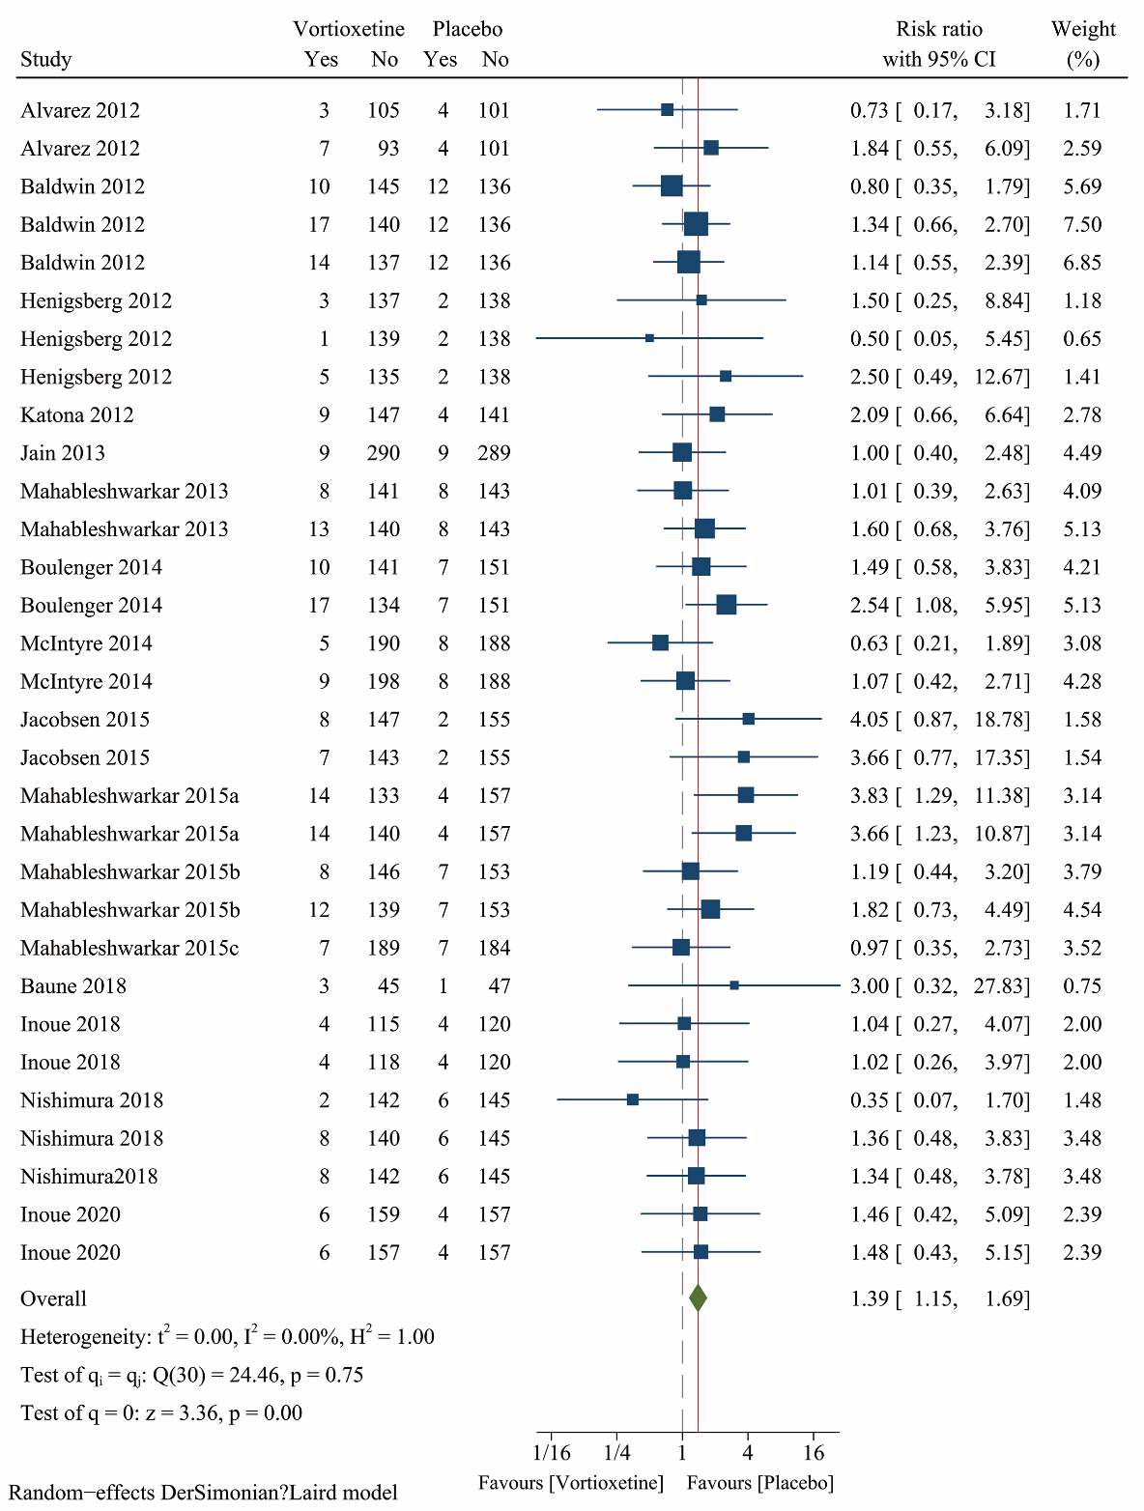

Supplementary Figure S12. Meta-analysis of vortioxetine versus placebo on adverse events: Subgroup analysis based on dose.
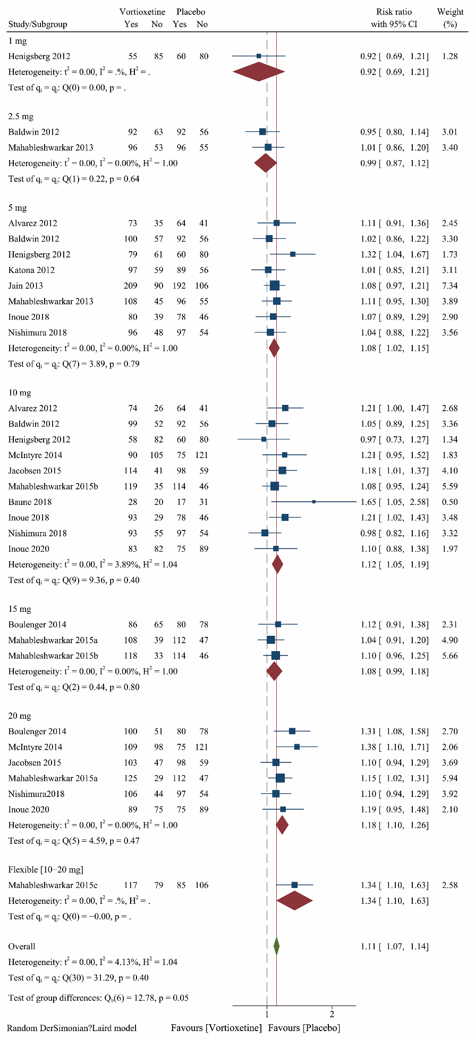

Supplementary Figure S13. Sensitivity analyses on the mean change in depression symptom scores.
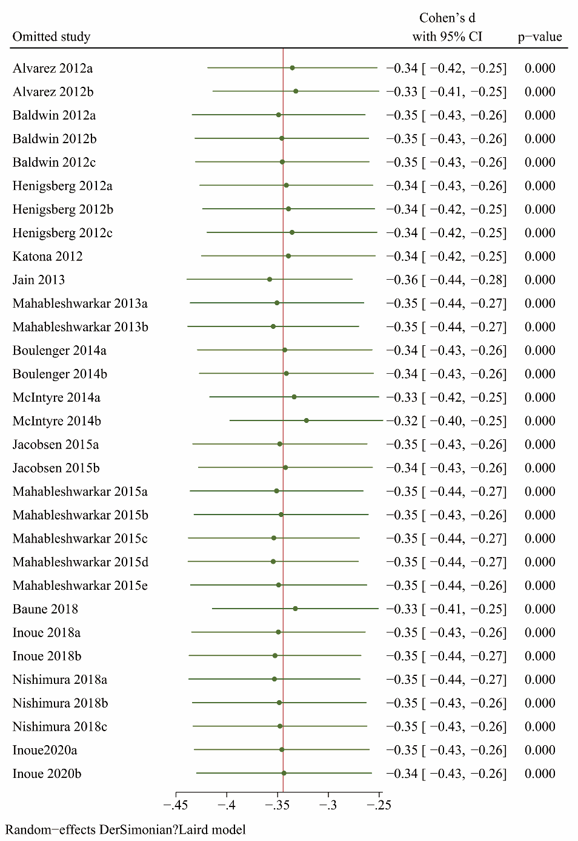

Supplementary Figure S14. Spline curves with different knots and their goodness-of-fit.
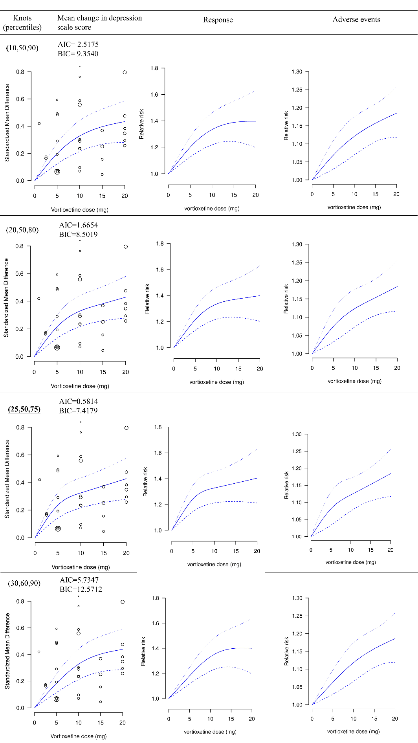
Abbreviations: AIC=Akaike Information Criterion; BIC=Baeysian Information Criterion. Bold and underlined shows the model with the best fit. The dash lines represent 95% confidence intervals.
Supplementary Figure S15. Dose-outcome curves for only fixed-dose studies. The dash lines represent 95% confidence intervals.
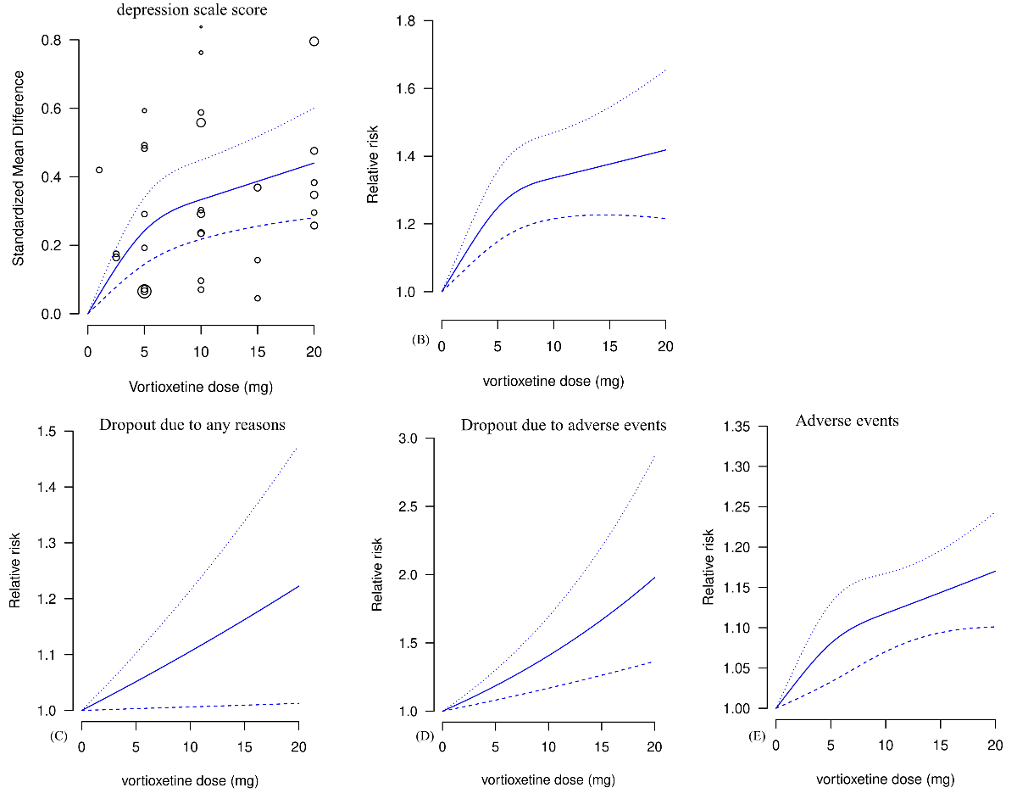

Supplementary Figure S16. Dose-outcome curves estimated using a one-stage (blue line), a two-stage (red line) restricted cubic spline model and a two-stage linear (green line) model.
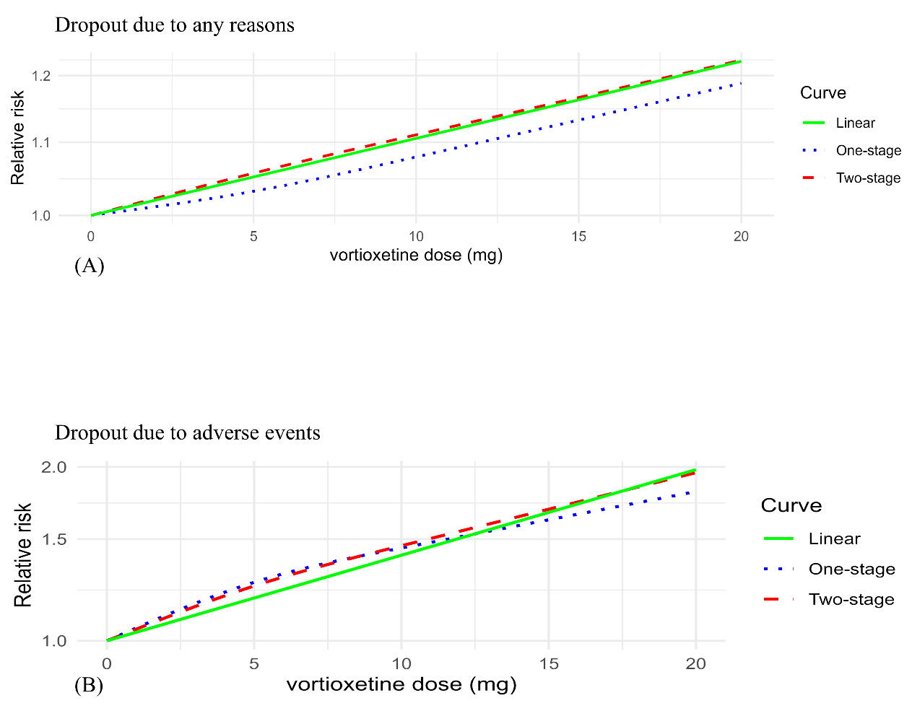

Supplementary Figure S17. Funnel plot for assessing the publication bias for mean change in depression symptom scores.
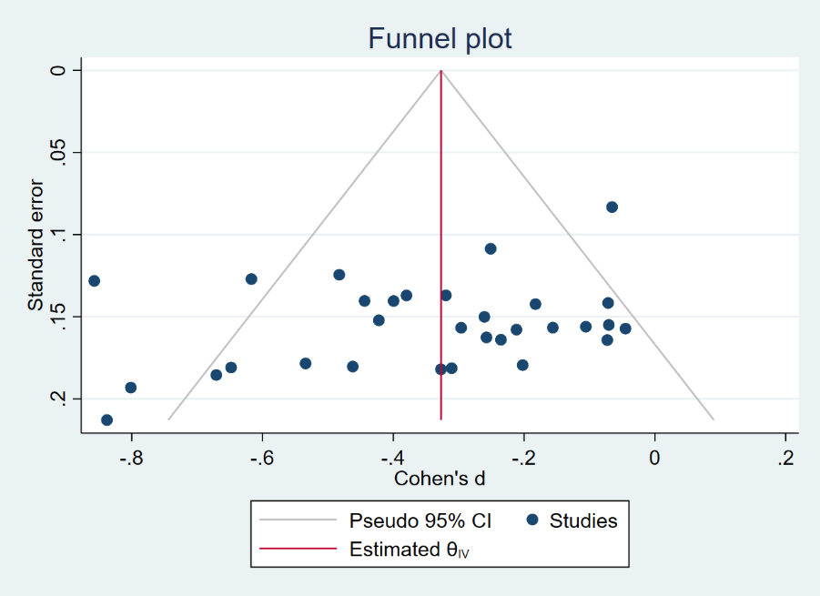

Supplementary Figure S18. Meta-analysis of vortioxetine versus SNRIs o mean change in depression symptom scores: Subgroup analysis based on different SNRIs.
